Our Products…
Scentsy presently offers over 80 fragrant scents and 30 exclusive and authentic Scentsy Warmers. In addition, we offer car fresheners, room sprays and travel tins

Authentic Scentsy Candle Bars…
Scentsy Bars are incredibly potent bars of highly scented wax. Because a flaming candle is never our problem, we can pack each Scentsy Bar with more fragrance oil than most 12 oz. jarred candles. With over 80 fragrances to choose from, there is one sure to please everyone. Each candle bar will last approximately 50 to 80 hours.
Authentic Scentsy Warmers…
Scentsy Warmers are specifically designed to perfectly melt Authentic Scentsy Bars into an impressive wax pool that throws the maximum amount of fragrance over the longest period of time. Scentsy Warmers melt wax at a lower temperature so there is never any danger of burning children or pets. With dozens of colors and styles to choose from, there is a Scentsy Warmer to fit every decor.

Our candle warmers are electric and heated with a 25 watt light bulb, included with purchase. This low watt bulb is hot enough to melt the wax, but not hot enough to burn if spilled.

Room Sprays…
Our Scentsy Fragrances are so fantastic; you will want to take them everywhere. We have designed other products to help you “Get Scentsy” in your car, closet, hotel room, or wherever you want a blast of your favorite Scentsy Fragrance.
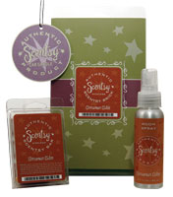
Let’s Compare…
Let’s compare why our products are a great value, in addition to being a quality candle with a tremendous scent.

First some facts from the National Candle Organization; U.S. retail sales of candles are estimated at approximately $2 billion annually, excluding sales of candle accessories. Candles are used in seven out of ten U.S. households. Two-thirds of candle purchasers say they use candles once a week or more often.
For our example below, we will use the above statistics as a guideline for our comparison. Let’s say an average household burns one candle a month with a burn time of approximately 50 to 80 hours.
Our Price Comparison for 1 Year of Fragrance…
Scentsy
Candle Warmer $25.00 plus 12 Candle Bars = $75.00 (1 Candle Bar Per Month - Tax & Shipping Not Included) Our Candle Bars burn an average of 60 to 80 hours.
Popular Candle Competitor
Jar Candle - 12 x $18.95 (16oz) = $227.40 (1 Jar Candle Per Month - Tax & Shipping Not Included) Candle burns an average of 60 to 80 hours.
Jar Candle $227.40 - $69.95 Scentsy = $152.40 Scentsy Savings!
Note: If Scentsy products are ordered through a home or book show, shipping is always FREE with a qualifying show of $150, saving you even more.
And you still have your beautiful candle warmer. It’s a one time purchase!
When you consider the safety and health benefits combined with the additional savings over a jar candle, why would you buy anything else other than Scentsy candle bars and warmers?
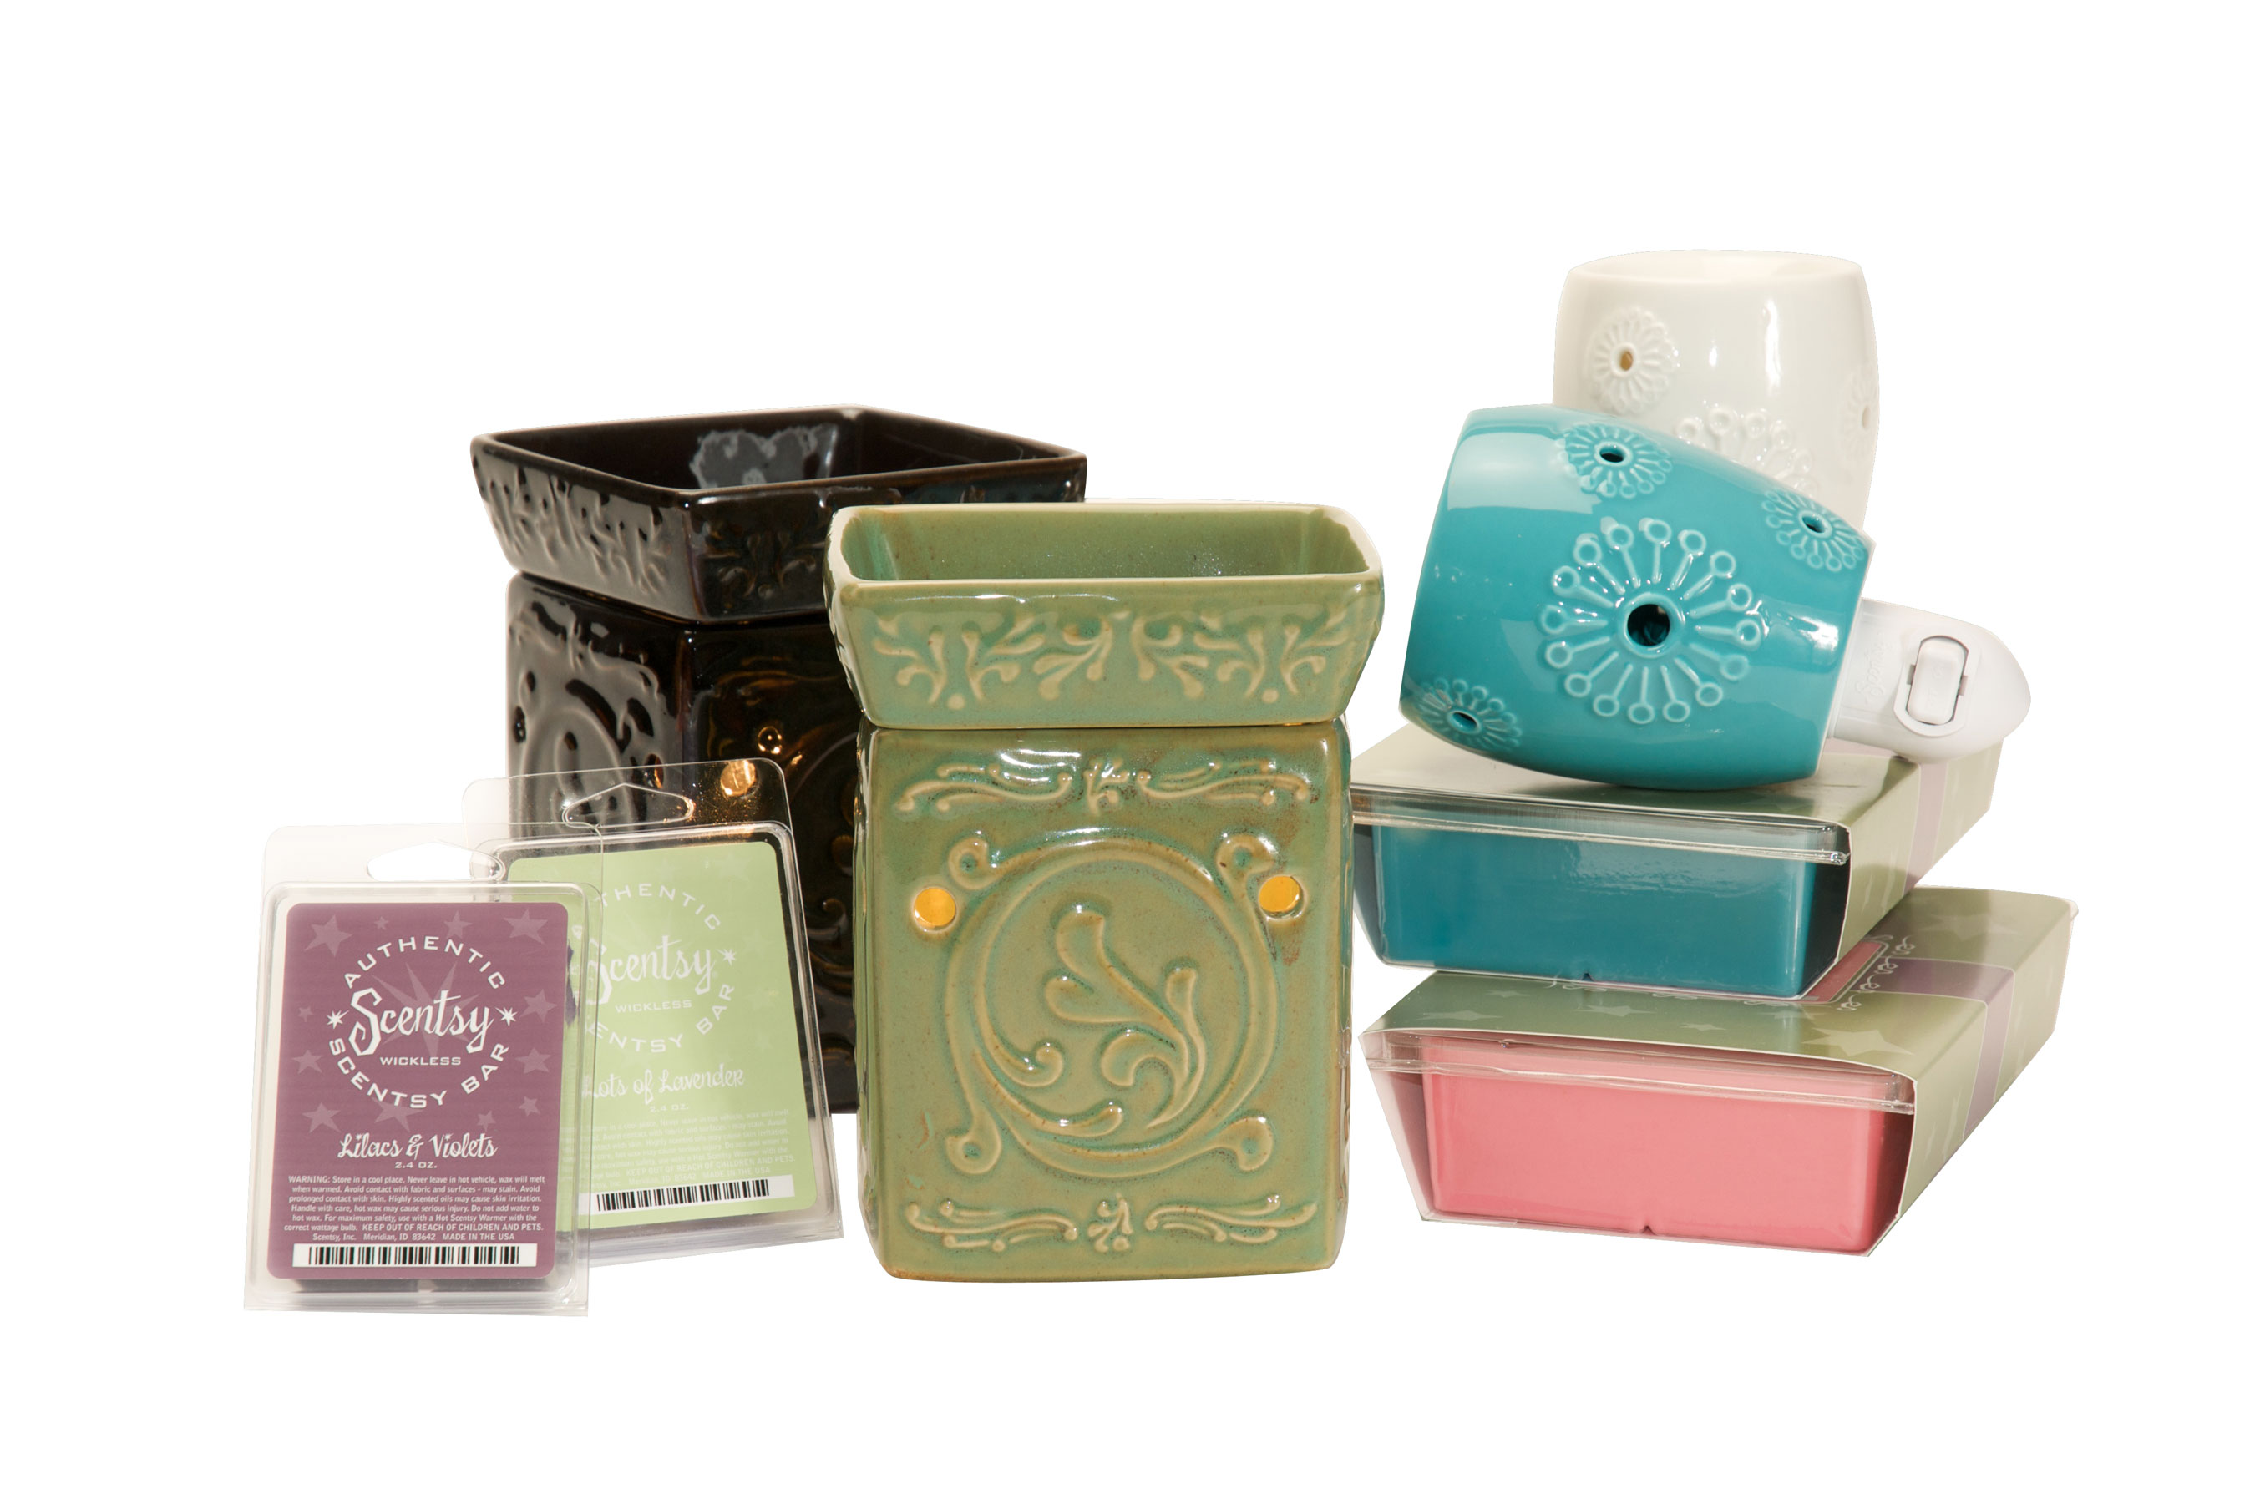
Why No Flame Candles?
Our Scentsy Wickless Candle Bars add a new level of safety to candle lovers everywhere, while still allowing you to enjoy the lovely aroma candles provide.

Here are just a few of the benefits you can expect by using our premium wickless candle bars:

- There is no open flame which means no danger of causing a fire around curtains or other combustible materials in your home or workplace.
- Also our wickless candle bars are safer around small children and pets when compared to standard open flame candles. Scentsy Warmers and Candles Bars burn warm to the touch, but not hot enough to burn children or pets.
- Our Wickless Candle Bars do not melt, just the scent evaporates. This means there is no danger of soot, lead or other chemicals being released into your home or workplace.

Scentsy Wickless Candle Bars and Warmers can be used in areas that typically do not allow candle burning…

- Business Offices
- Dorm Rooms
- Doctor’s Offices
- Classrooms
- Great for Realtors
- Daycares & Nurseries
- Just About Any Place

In addition to being a fire hazard, improperly used wicked candles can generate a significant amount of soot. This soot can damage the walls, floors and ceilings of your home as well as your personal belongings. With Scentsy, there is never any danger of this happening with our wickless candle bars.

Bottom line, Scentsy Wickless Candles have NO smoke and NO open flame, thus are safer to use and ensure a more efficient release of fragrance.

Could Scentsy Be Your Business?

Starting your own business, as an Independent Scentsy Consultant, offers income and time flexibility without interfering with your current job, your family, or your already-busy schedule.
Because of Scentsy, some of our Consultants have been able to:
- Say good-bye to an unbearable job.
- Stay home to raise children.
- Pay off debts.
- Find time for things they truly want to do.
- Take a vacation.
- Afford new cars, computers, cell phones, dishwashers, and other nice things.
- Save for college expenses.
- Make new friends and network with other good people.
- Spend more quality time with family and friends.
- Enjoy life more.

If any of these things appeal to you, then you owe it to yourself to read this carefully, and contact Erin Hitzeman, by phone at 214-546-7038 or via email at getwicklesswitherin@gmail.com.
I look forward to answering your questions and helping you decide whether this business is the perfect fit for you, your family and lifestyle.
Work at Your Pace…
The best thing about a Scentsy business is that it's not a "one size fits all" opportunity. You are in control and can tailor this business to your specific needs.
Some Independent Consultants work full-time, while others work part-time and just dabble in the business for a little extra income now and then.
Some Consultants build their business online, while others build their business locally.
Some of our Independent Consultants are professional career people with full-time jobs, who build their business a few evenings each week or on weekends.
Some are stay-at-home parents, who build their business around their family schedules. No matter what your lifestyle, a Scentsy business can fit your routine and schedule.
Independent Consultants can earn immediate income, monthly bonuses, and long-term residual income (which means you can get paid for years to come on work you do now). Plus, there are incentives and contests in which Consultants can earn additional income and other rewards.
Scentsy is a perfect career choice offering flexibility to work around your busy life.
Ways to launch your Scentsy business…
- Hold a Scentsy Open House
- Basket Parties
- Online Sales
- Expos & Events
- Home Parties
- Marketing to local Realtors, Doctors Offices, Businesses, Daycares and etc.
- The Possibilities are Endless
As a Scentsy Independent Consultant, it's possible to earn the income you need, while still being in total control of your time.
Ready to get started? Join online at https://hitzeman.scentsy.us.
How We're Different…
You may be wondering what makes Scentsy different then the other home businesses you have been considering.
- Our team of Independent Consultants is a friendly, family-oriented group. We are supportive and believe in helping one another.
- A Scentsy business gives you flexibility. You are in complete control of how much or how little you work your business.
- You don't need any previous experience. We offer excellent training and support that can help you succeed in a step-by-step manner. This includes conference calls, a private training website, promotional tools, and more.
- Your efforts are rewarded by an outstanding compensation plan. From the day you start, there’s plenty of immediate potential income from marketing the products.
- FREE Shipping on Business Supplies – Scentsy offers free shipping on all Consultant business/paper supplies. This saves you money.
- FREE Shipping on Qualifying Personal, Home Parties or Books Shows – Qualifying orders or shows of $150 or more receive FREE shipping! The only exception is Hawaii and Alaska which are charged 10% shipping.
Direct ship to a customer is only 10% with the exception of Hawaii or Alaska. Direct ship to those two states is 20%.
- Host Rewards – All Host Rewards are paid by Scentsy. A $5 Host Shipping -Party Fee can be paid by either the Host or the Consultant. One idea is to use this as a thank you for your Host. Let them know there is a shipping cost, but you will cover this as a thank you for hosting their show.
- Scentsy Candle Bar Ingredients - Many customers have asked about the wax we use and why. Here is the scoop. We use a food-grade petroleum based wax. We chose this wax because of its superior scent loading ability, melt point and firmness. We looked into vegetable based waxes, and we just couldn’t get a quality candle bar.
The type of wax we use is a non-issue, with regard to the chemicals released while burning. We only warm the scent out of the wax – the wax remains in the warmer, thus there is no danger of chemicals being released into the home.
What’s in Your Scentsy Starter Kit?
Your initial investment to start your Scentsy business is not a burden…only $99 (does not including shipping and local tax). When you join Scentsy, as an Independent Consultant, you receive:
- 1 Consultant Handbook Binder (Inserts to be Downloaded)
- 3 Months Personal Website Subscription ($10 Monthly Thereafter - Optional)
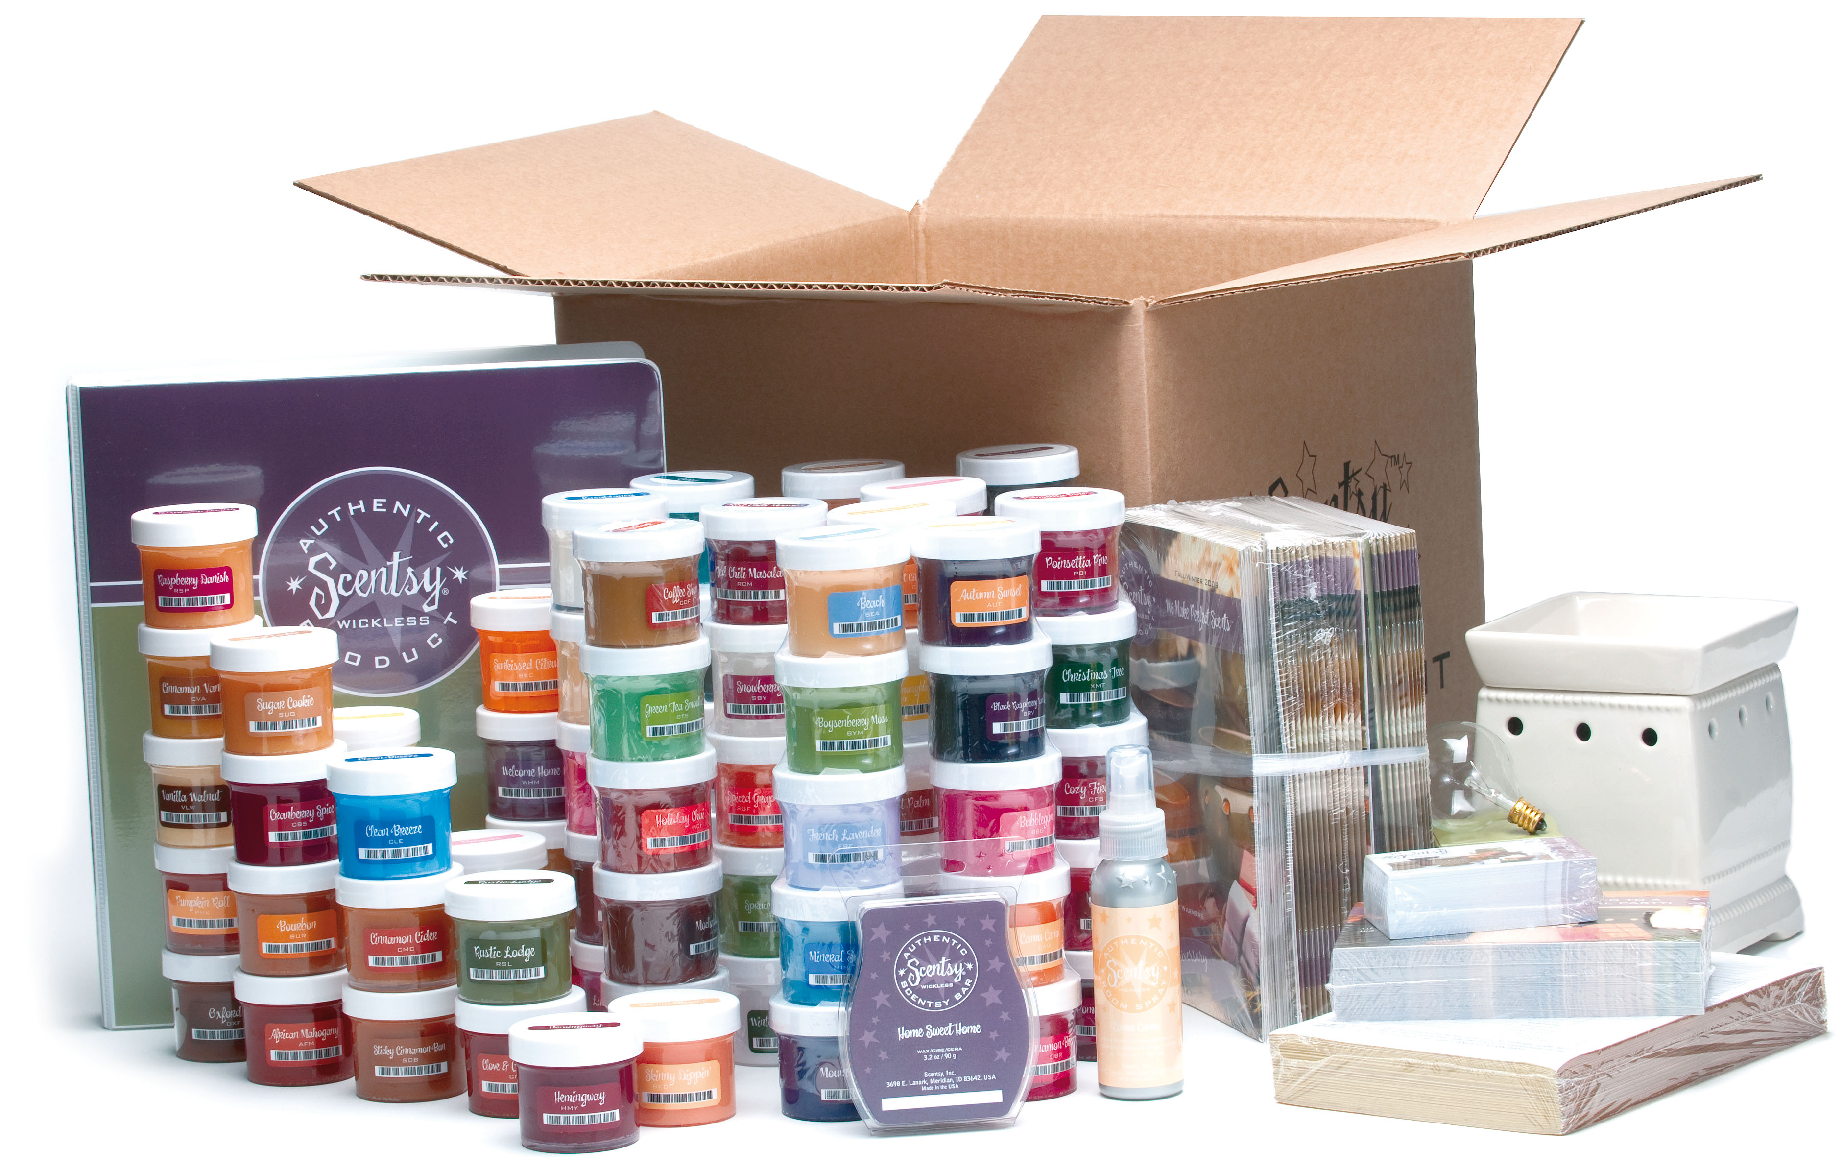
- 1 Warmer, Candle Bar & Car Candle
- 1 Room Spray
- 80 Party Testers (1 Full Set, Scent of the Month Testers Not Included)
- 100 Business Cards
- 100 Invitation Postcards
- 100 Customer Order Forms
- 25 Catalogs
This business can be a blessing for your family. In addition to being a fun way to give yourself more income and more time flexibility, this business will also let you use the Scentsy products at a substantial discount. Plus, you may find that having your own business can give you significant tax savings year after year. Put it all together, and you have an unbeatable way to create a better life for yourself and your family.
It's easy to get started, either with a phone call or online at https://hitzeman.scentsy.us. Contact me by phone at 214-546-7038 or by email getwicklesswitherin@gmail.com .
Once you join, send me an email at getwicklesswitherin@gmail.com. I want to help you get started right with the many valuable tools we have available on our online training website and team forum.
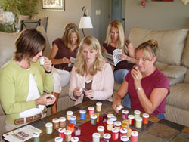
Host a Show - Host Rewards
Scents are like notes that, when played together, strike beautiful chords that have an amazing affect on our mood, attitude and well-being. The sense of smell is very powerful. One wisp of a fragrance can calm, relax, invigorate, or inspire. The smell of fresh baked cookies, clean laundry, or fresh flowers brings to mind wonderful memories. In short, fragrances warm the heart, enliven the senses, and inspire the soul.
All Scentsy products are chosen, designed and crafted to provide customers with a superior fragrance experience without sacrificing health, safety, or style. Hosting a Scentsy Candle Party is a great way to earn fantastic rewards. Take a look at what you can earn by hosting your own party.
What You Earn with Total Party Sales from...
- $150 to $249 - 10% in Free Product, Plus (1) ½ Price Item
- $250 to $399 - 10% in Free Product, Plus (2) ½ Price Item
- $400 to $999 - 15% in Free Product, Plus (3) ½ Price Items
- $1000 Plus - 15% in Free Product, Plus (4) ½ Price Items
We also offer a monthly Hostess Special and our Scent of the Month Promotion.
And don’t forget, FREE SHIPPING on all qualifying shows of $150 or more. Your guests pay only for their products…no shipping charges.
Scentsy Support
Your Scentsy business starts with the commitment from a company that believes in supporting their Consultants and is open to listening to new ideas and suggestions. They support you, so you can devote your time and energy to growing your business.
When you join Scentsy, your family immediately benefits from a minimum discount of at least 20%. Call a toll-free number or log on to the internet and place your order.
And don’t forget Scentsy offers promotions to earn free products when you join, plus the Scent of the Month and on-going Consultant and Hostess Specials.
Team Support
Being a member of our team is really your secret for success. We focus on having fun, helping friends, creating wealth, and reaching dreams. And we provide plenty of encouragement and support for our Consultants. Our team offers:
- Training E-Books for Basket & Home Parties
- Team Forum
- Team Yahoo Group
- One-on-One Coaching and Training
- And More!
As a member of our Scentsy Team, you can get personal assistance from the person who gave you this E-book and from experienced Scentsy leaders. So, even though you will be your own boss, you’ll know exactly where to get answers, advice and encouragement.
Great Marketing Materials
Scentsy offers beautifully designed packages for all their products along with quality marketing materials. In addition, Consultants are fortunate to have Scentsy Success designs to enhance their business. Take a peek at these beautiful marketing materials: www.ScentsySuccess.com.
How You Earn Money with Scentsy
Scentsy rewards you when your efforts result in more families using Scentsy products. There are three main ways this happens.
Build a Team of Independent Consultants.
Building a team is the most powerful way to earn money with Scentsy, because you can help many more families obtain Scentsy products than you ever could by working alone. As your team duplicates your efforts by introducing this business and the products to others, you can earn a percentage of the product volume generated by your entire group.
The best part about establishing a team, however, is that your income isn't just based on your efforts—it's based on the efforts of everyone in your group. That's the power of residual income!
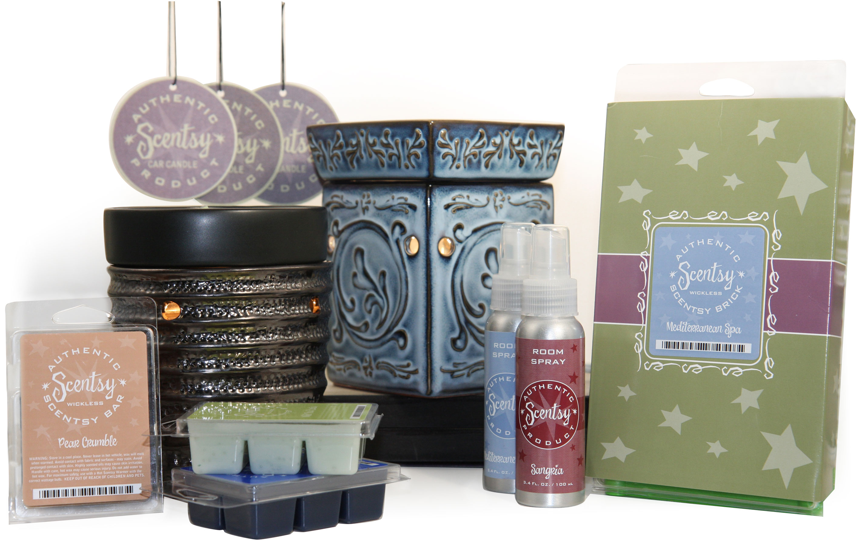
Here is a quick overview of the Scentsy Compensation Plan.
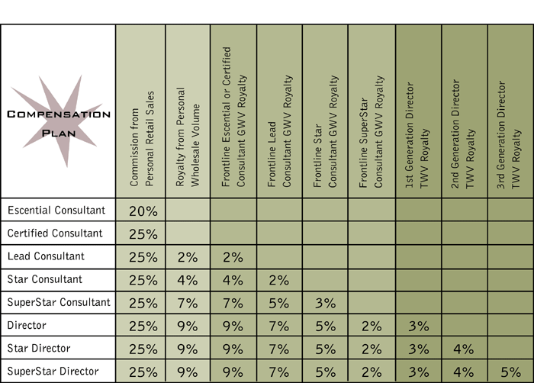
Consultants have the opportunity to earn over 30% on personal sales and receive leadership bonuses of up to 9% of the entire down line volume of the people you recruit and train.
With just $1000 in personal sales you promote to 25% commission, on retail orders, and you never go back!
Independent Consultants submit payment, in full, for shows/products and then are issued their earned commissions on the 10th of each month. If you have not earned $30, then your earnings will be carried over until the next pay period or once you reach $30 in commissions.

To remain an active Independent Consultant

- Sell $150 per quarter ($150 must be earned in one month, in a 3 month period).

You can accomplish this easily with one home show, online sales or a book party.

