How to Make Scentsy Wax Samples

There are numerous ways that Scentsy consultants make their samples. The information contained below is just one way. Take what you like and discard the rest!
Why and how I use samples –
I don’t let any of my business cards leave my hands without having a wickless candle sample attached to it. People generally desire to smell, touch, taste, or hear something before they’re truly sold on it. Scentsy is no different.

Where I get the wax to use –
I don’t pay for the wax I use to make samples. When I place an order I always make sure it’s at least $150 or more so that I can take advantage of the hostess benefits, including free and half off items. The wax I get with those perks is what I use to make the samples. Generally I like to use the bricks, as it’s a better value; but I have also been known to use bars sometimes too.

What scents I use –
I have a couple standards that I like to use: Camu Camu, Clean Breeze and Vanilla Suede. I chose those because they are drastically different from each other. Clean Breeze and Camu Camu are in the Favorites category so those are definitely flagged as popular. Vanilla Suede is a bit of a masculine/leather type scent and unique on its own. It doesn’t really matter what scent(s) you choose to use. No matter what – some will love it; and others not. Other favorites include: Black Raspberry Vanilla, Welcome Home, Skinny Dippin, White Tea & Cactus.
The process –
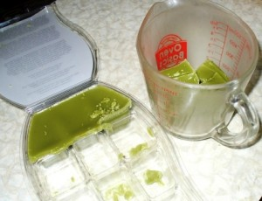
- I generally start with a brick. Then chunk off some wax with a butter knife, enough to fill a microwave safe dish. I use a 2 cup Pyrex. (Shown here Rustic Lodge brick)

- Microwave long enough to liquefy the wax – approx. 2-3 minutes. (Shown here Clean 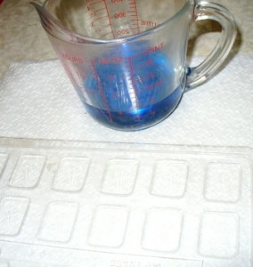Breeze bar)

- Pour the liquid wax into candy plastic molds. You can generally find the molds at craft stores such as Michael’s or Hobby Lobby or various places online. You can often times grab a coupon to these stores for 25-40% off their websites. The shape of mold you use is up to you. Some people like to get fancy and use hearts around Valentine’s Day or leaves in the fall, etc. I mail many of my samples, so I have chosen to use very plain, simple rectangle molds – similar to the Andes chocolate mints you get at restaurants with your bill. This way they are thin enough to avoid paying extra postage due to the USPS surcharge.
- I allow them to sit on the counter for a few minutes to start to harden. When I can safely move the wax filled molds, I put them into the freezer for about 5-10 minutes to finish hardening. This step also allows them to easily pop out of the molds by merely turning 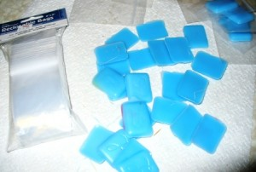them over.
- While the wax is in the freezer I prepare my business cards, annotating them with the scent of the sample. I prefer simplicity and to work smarter, not harder. Therefore I have a couple of self inking stamps that I ordered from vistaprint.com. They are offered for FREE quite frequently – I just pay the price of postage which is generally $5 (+/-) depending on if you order other free items as well. The stamps I ordered simply have the name of the scent on them – that’s it, such as Clean Breeze. I set out a couple rows of business cards on the counter and in assembly line fashion stamp many at one time. By the time the wax is ready to come out of the molds, the ink has also adequately dried on my biz cards, so that they won’t smear. 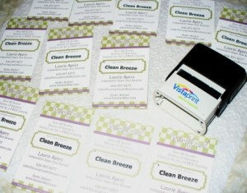
- My samples are then placed into 2” x 3” bead bags. These tiny zip lock bags can also be purchased at craft stores, Wal-Mart, Target, or online. I paid $1.09 for 100 bags at Meijer.
- The sample is then stapled to the back of my business card. I have heard of some consultants using larger bags and placing their business cards inside the ziplock. I don’t care for that method because the card could become oily or goopy if the wax melts. Also I think it’s easier to rip the sample off, then actually place it in a warmer, or purse, wallet, glove box, drawer, linen closet, etc. and then keep the card handy for future use.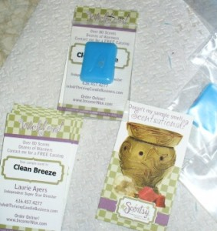
- The end. Samples made.
Where do I leave samples?
Look for a future post addressing this issue. I have lots of ideas. For now, I just wanted to put it out there how I make mine. As I mentioned, there are many ways you can make samples. This is just one method.
People often ask me what have I found most beneficial in building my Scentsy business. The two tools that have helped me the most are 1: This www.thrivingcandlebusiness.com website and 2: samples.
Keep it simple!

